# Web Technologies and Development

Student Name: Nicholas Lane

Student Number: 221156236

Task: 6.1 Dkn Pizza JavaScript

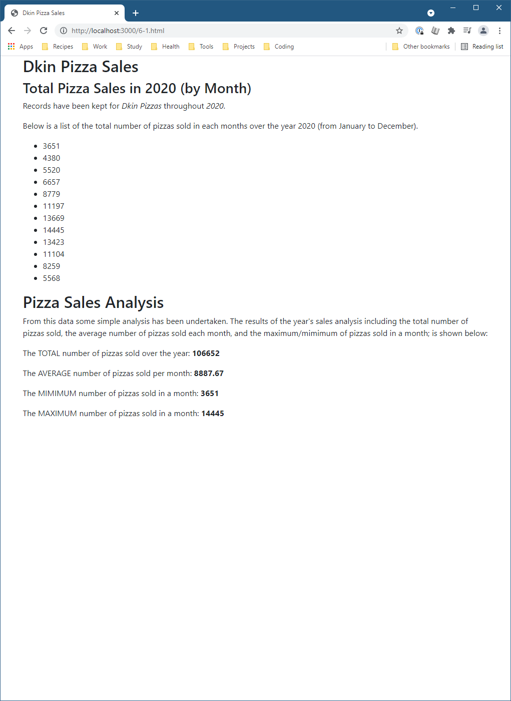

-- Document End --